**PRACTICAL 1**

Q1)

1. Scatterplot of advertising expenditure against quotations along with the regression line:

data1 = read.csv('insurance.csv')

head(data1)

plot(data1$TVadverts, data1$Quotes)

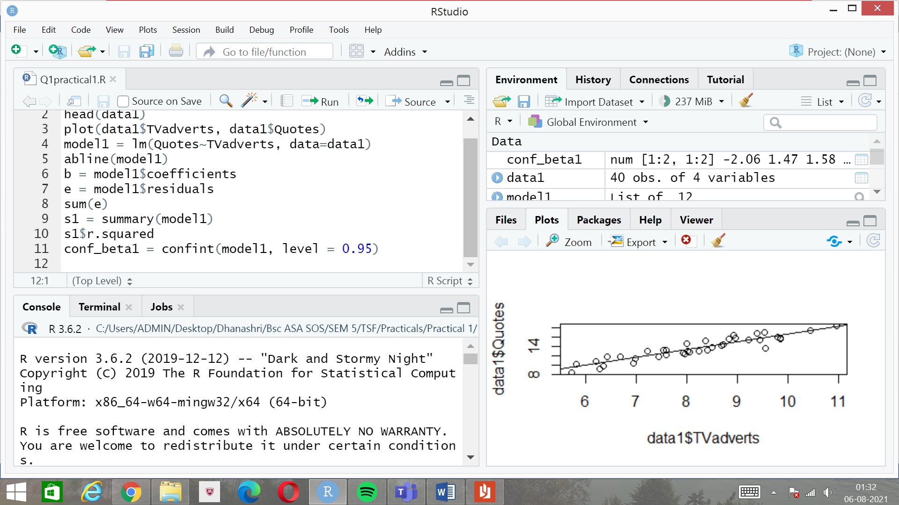

1. Linear Regression model fitted:

model1 = lm(Quotes~TVadverts, data=data1)

abline(model1)

b = model1$coefficients

e = model1$residuals

sum(e)

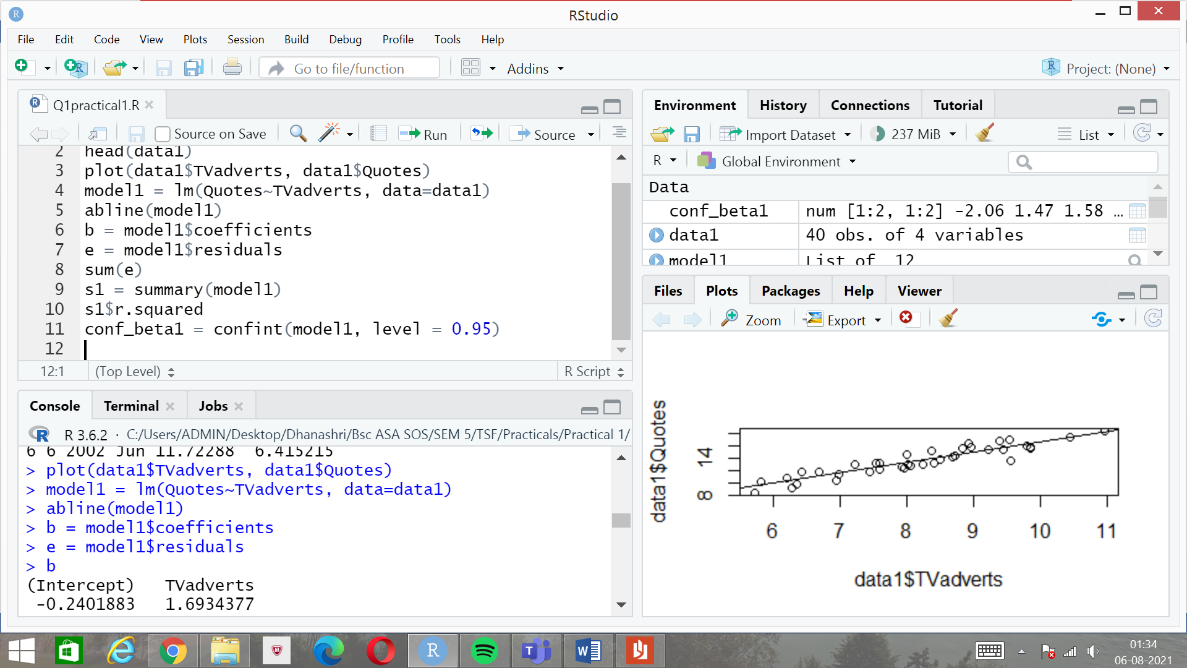

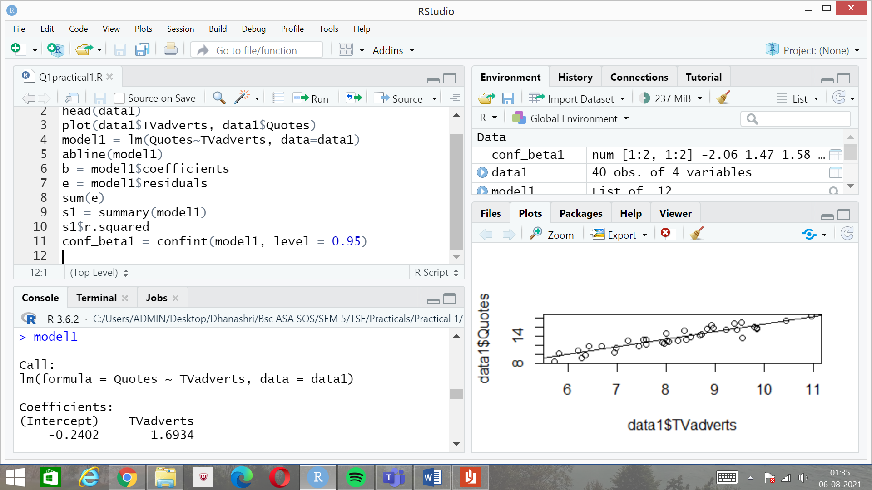

1. The p-value is < 2.2e-16. As p-value is less than the significance level 0.05, we reject the null hypothesis that beta is equal to 0.The value of beta is not equal to 0.

s1 = summary(model1)

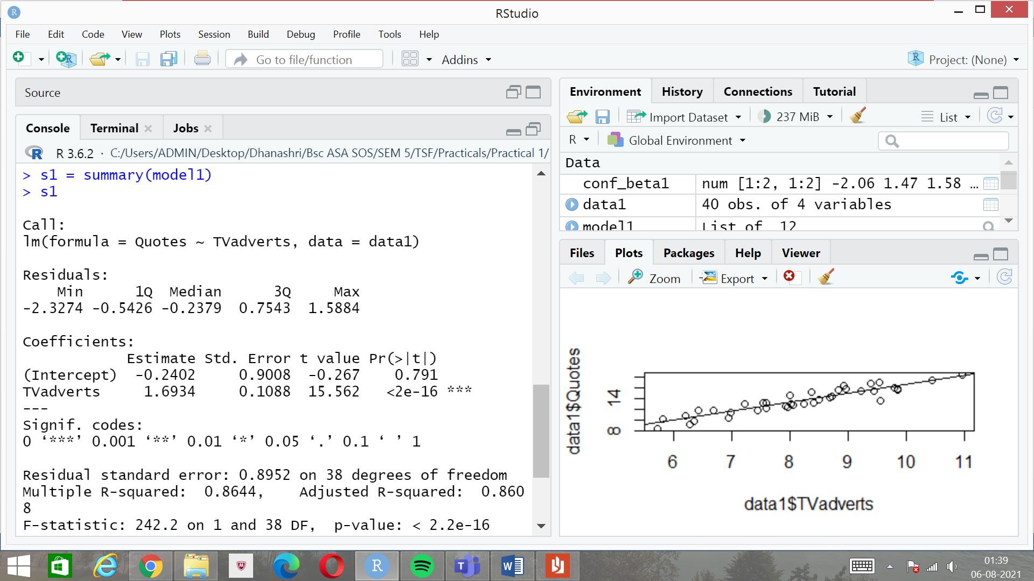

1. R-squared value:

s1 = summary(model1)

s1$r.squared

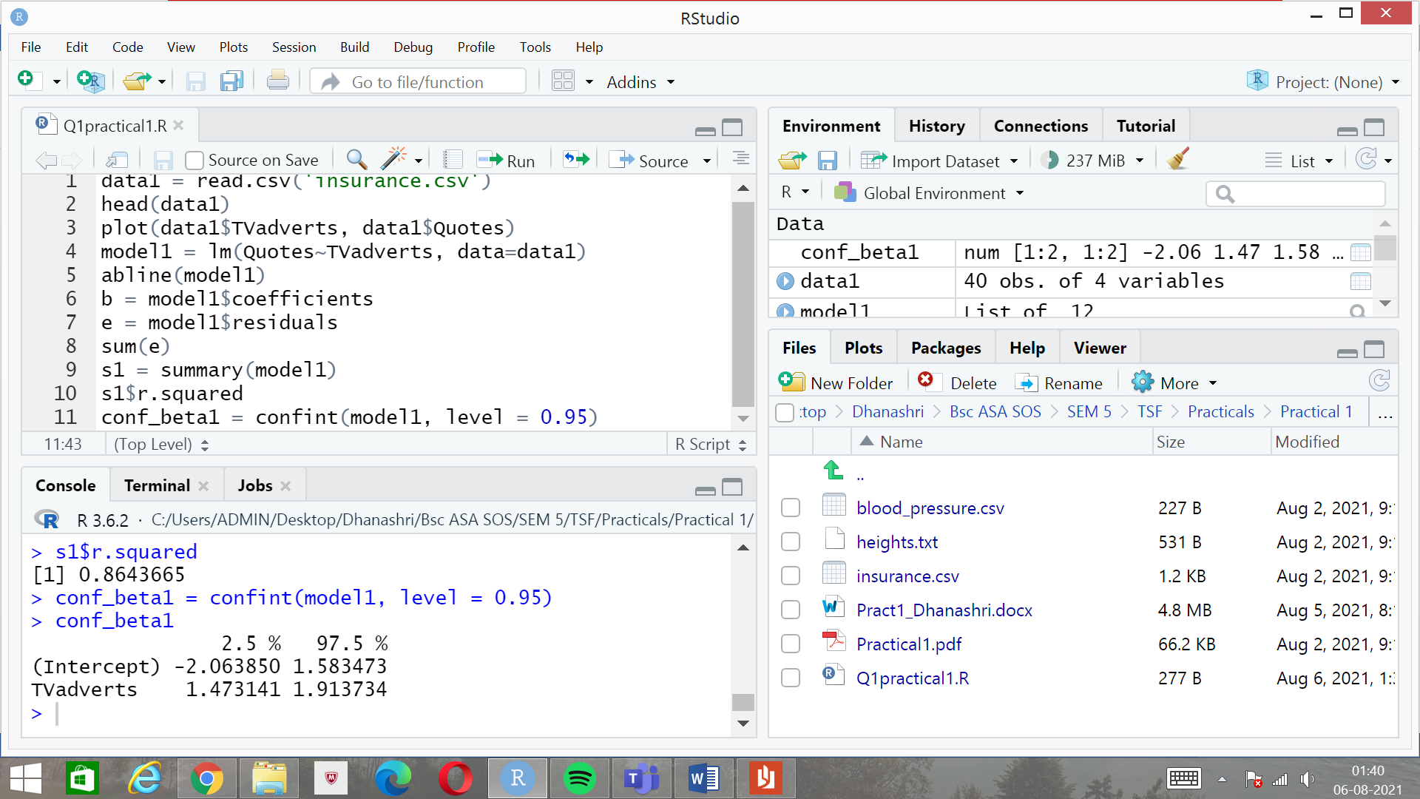

1. 95% confidence interval:

conf_beta1 = confint(model1, level = 0.95)



Q2)

1. Scatterplot of the variables:

data2 = read.csv('blood_pressure.csv')

head(data2)

plot(data2$Weight, data2$Systolic.BP)

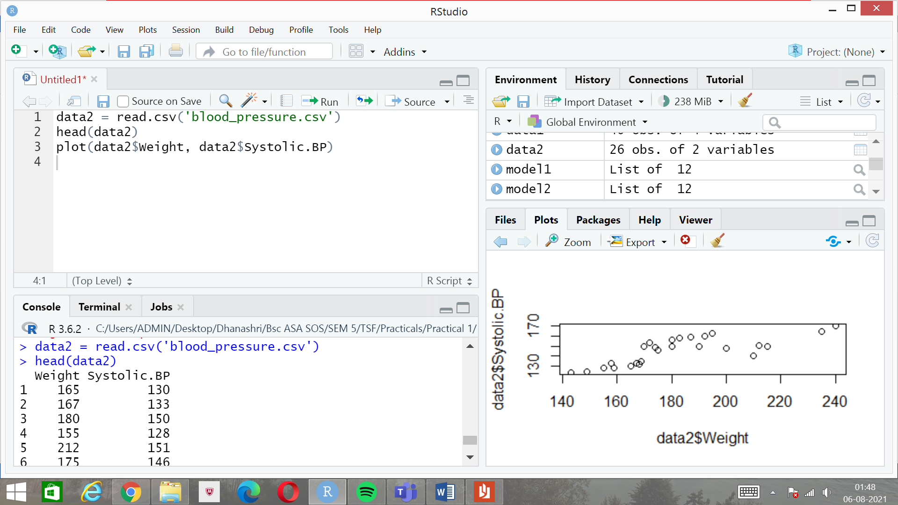



1. Linear regression model fitted:

model2 = lm(Systolic.BP~Weight, data = data2)

abline(model2)

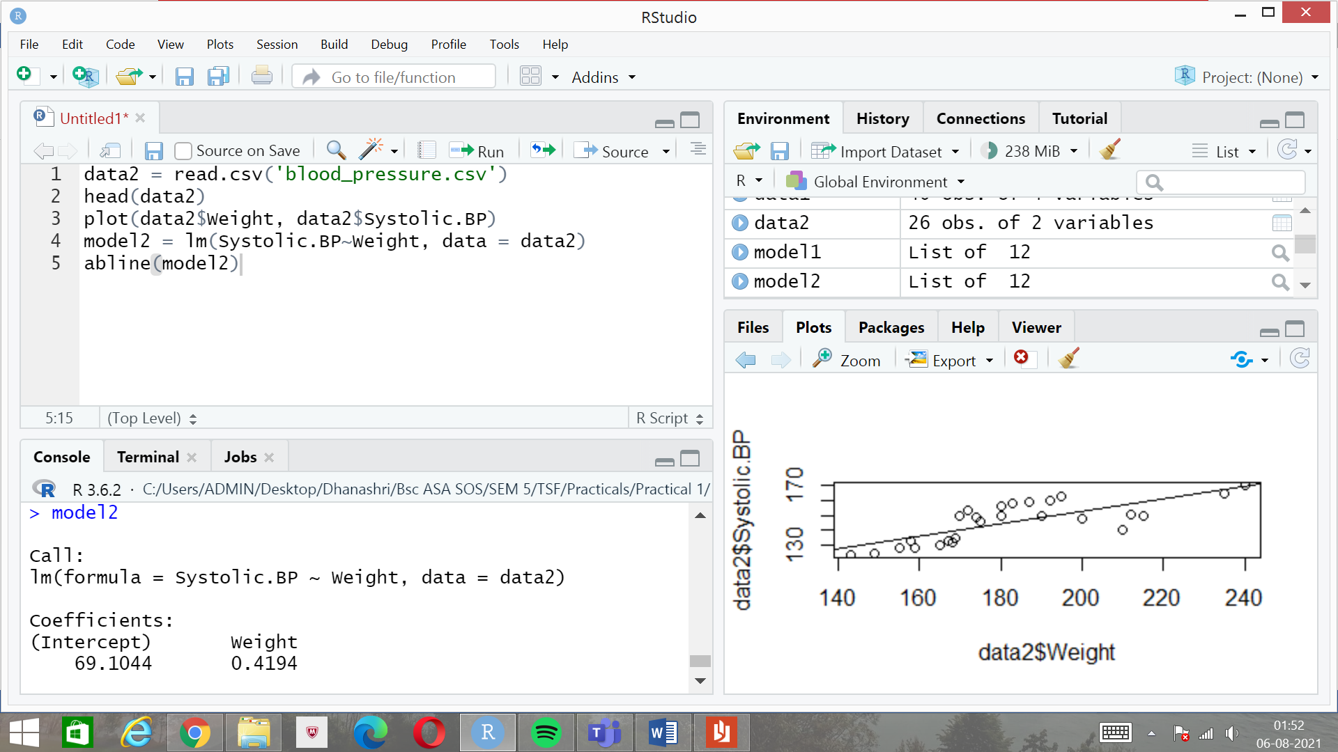

Regression line along with the scatterplot:



1. ANOVA table and testing whether the regression is significant or not:

anova_table1 = anova(model2)

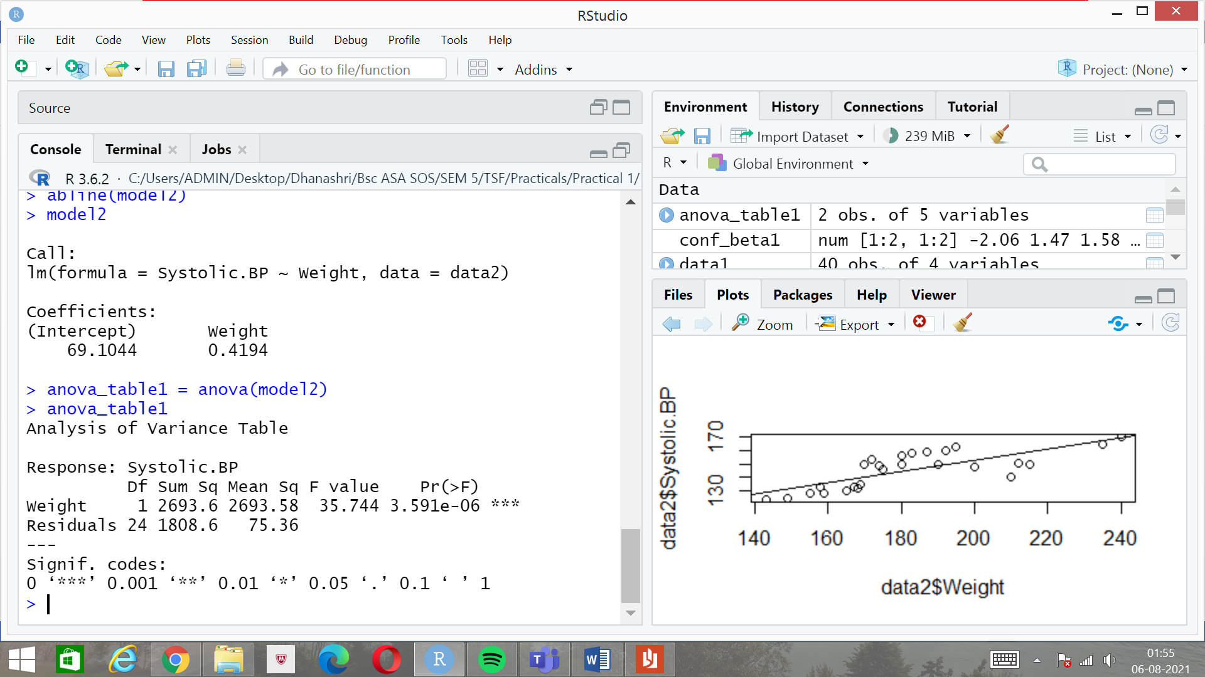

As the F-tabulated value is less than F-calculated, we reject the null hypothesis.

1. 90% confidence interval of slope:

conf_beta2 = confint(model2, level = 0.90)

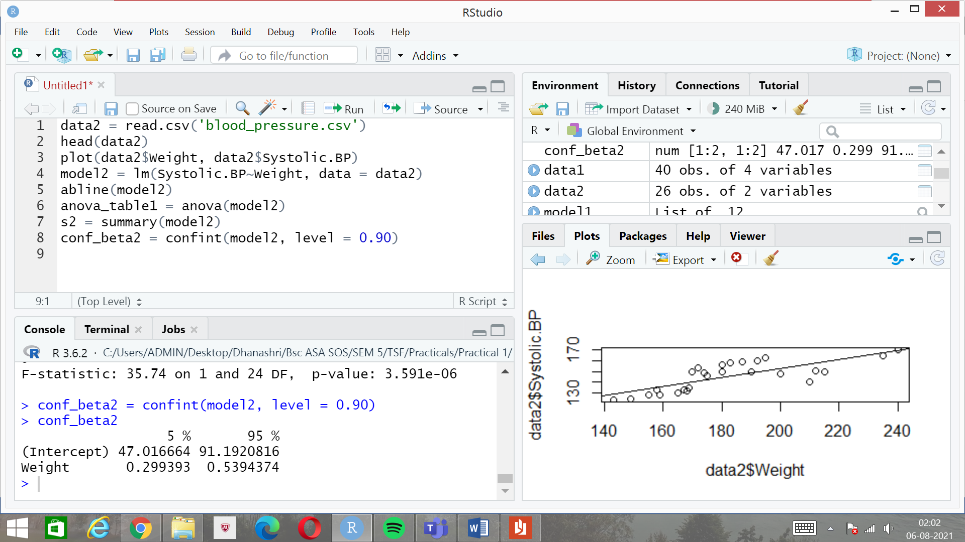

1. Variability percentage:

s2 = summary(model2)

s2$r.squared

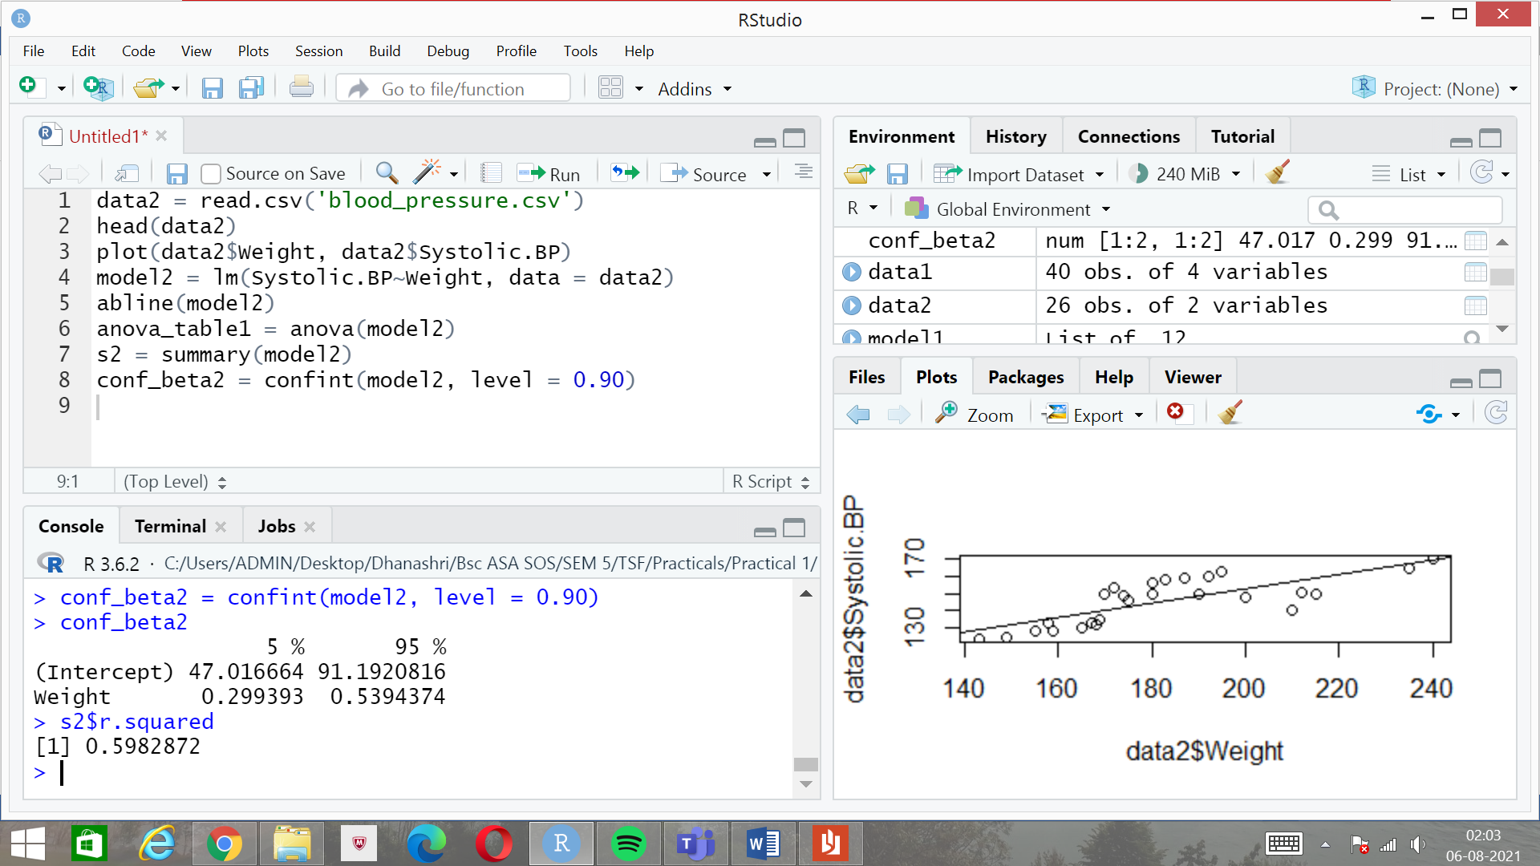

1. 90% CI for mean systolic BP when weight is 150:

new_data = data.frame(Weight = c(150))

predict_CI_new = predict(model2, interval = 'confidence',level = 0.90, newdata = new_data)

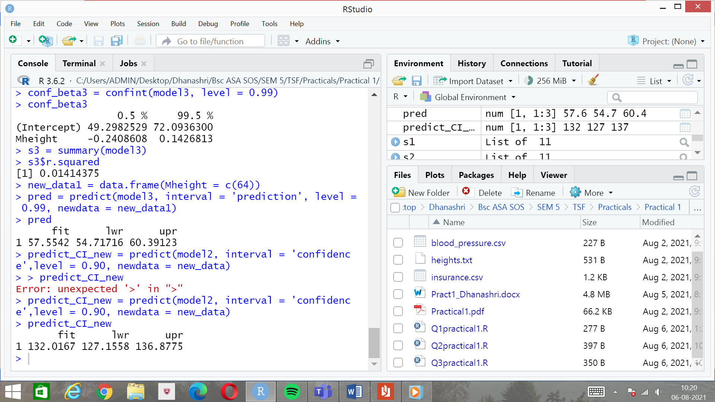

Q3)

1. Scatterplot and a regression model fitted:

data3 = read.table('heights.txt')

plot(data3$Mheight, data3$Dheight)

model3 = lm(Dheight~Mheight, data = data3)

abline(model3)

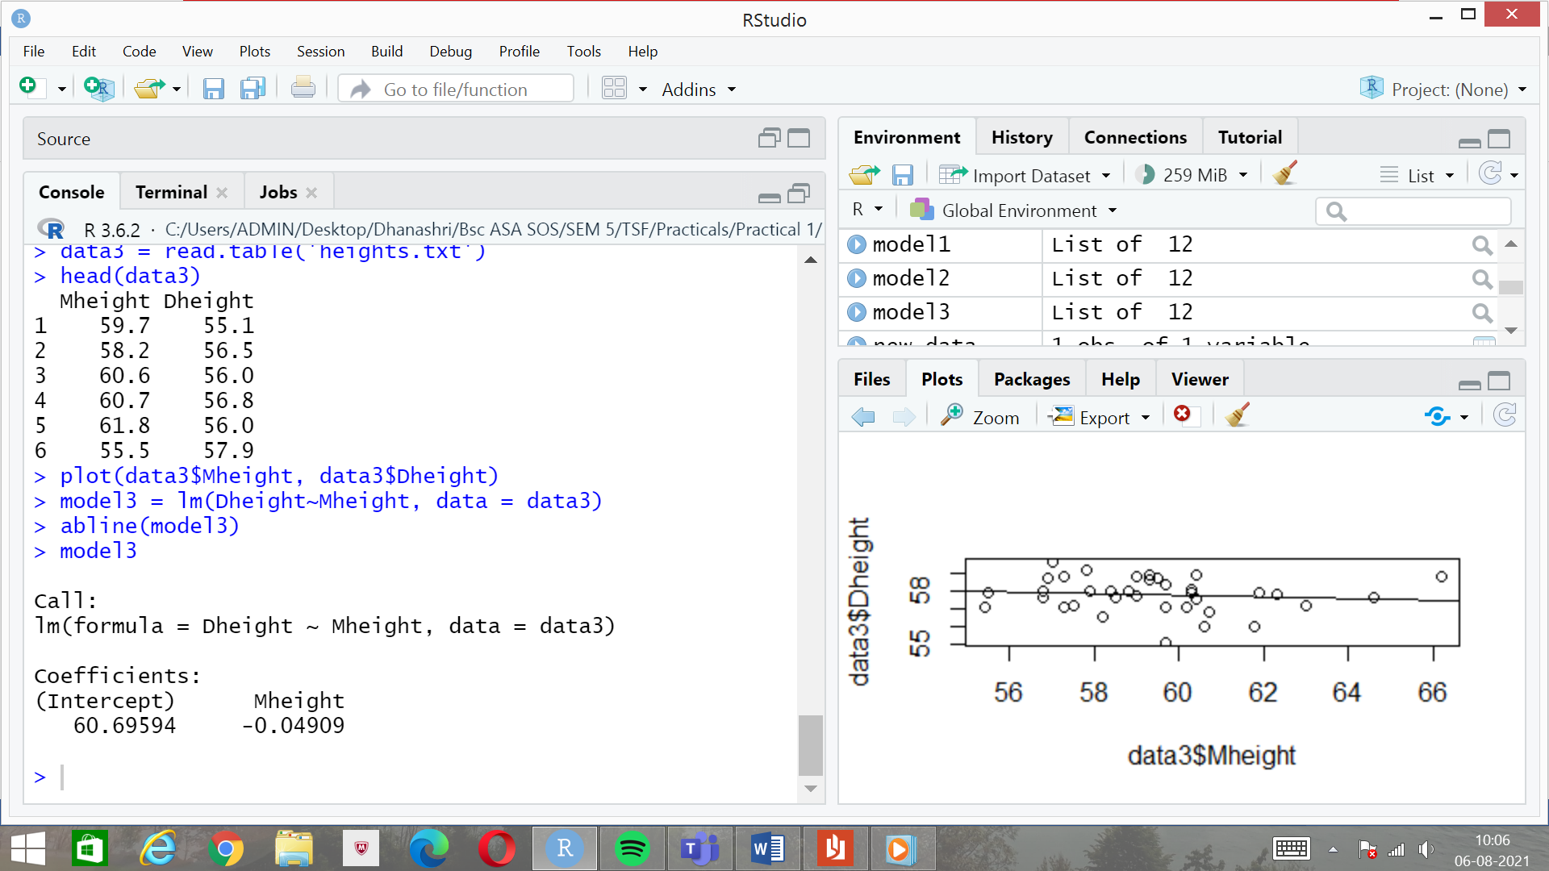



1. 99% CI for slope:

conf_beta3 = confint(model3, level = 0.99)

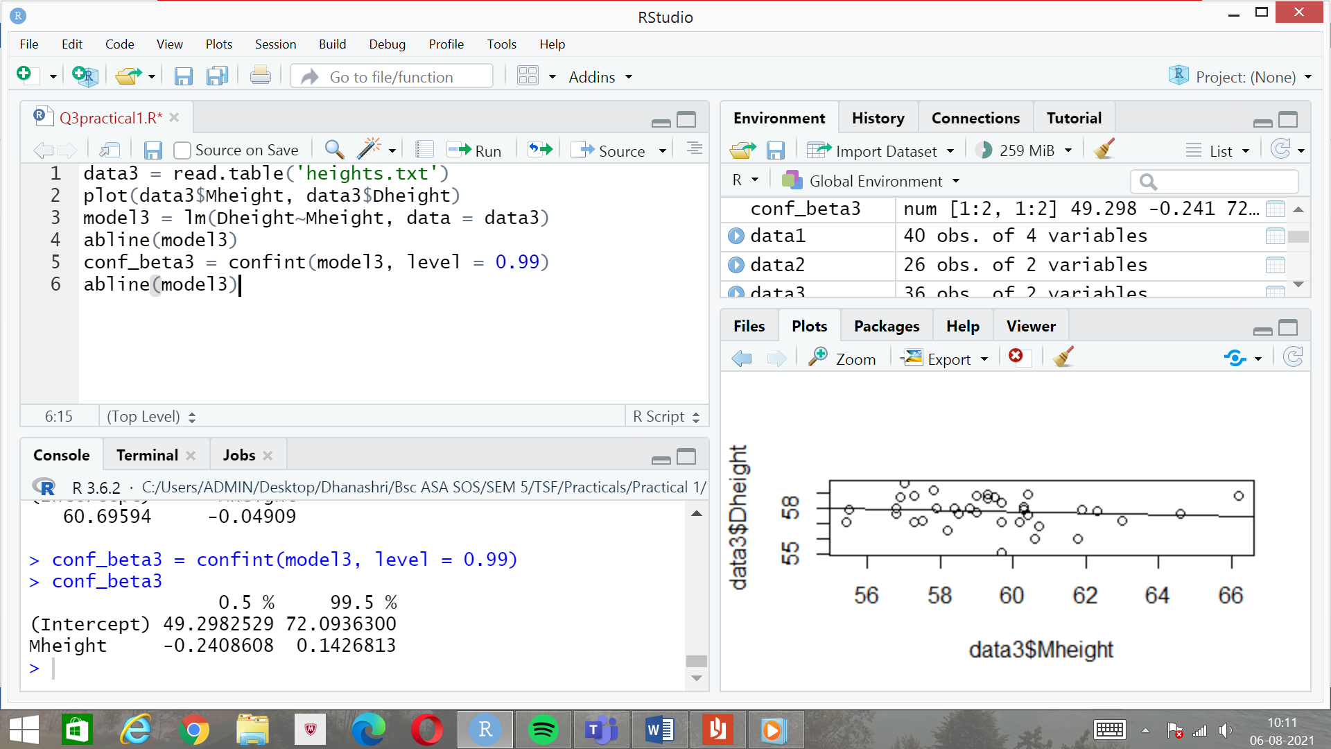

1 is not included in the confidence interval.

1. R-squared value:

s3 = summary(model3)

s3$r.squared

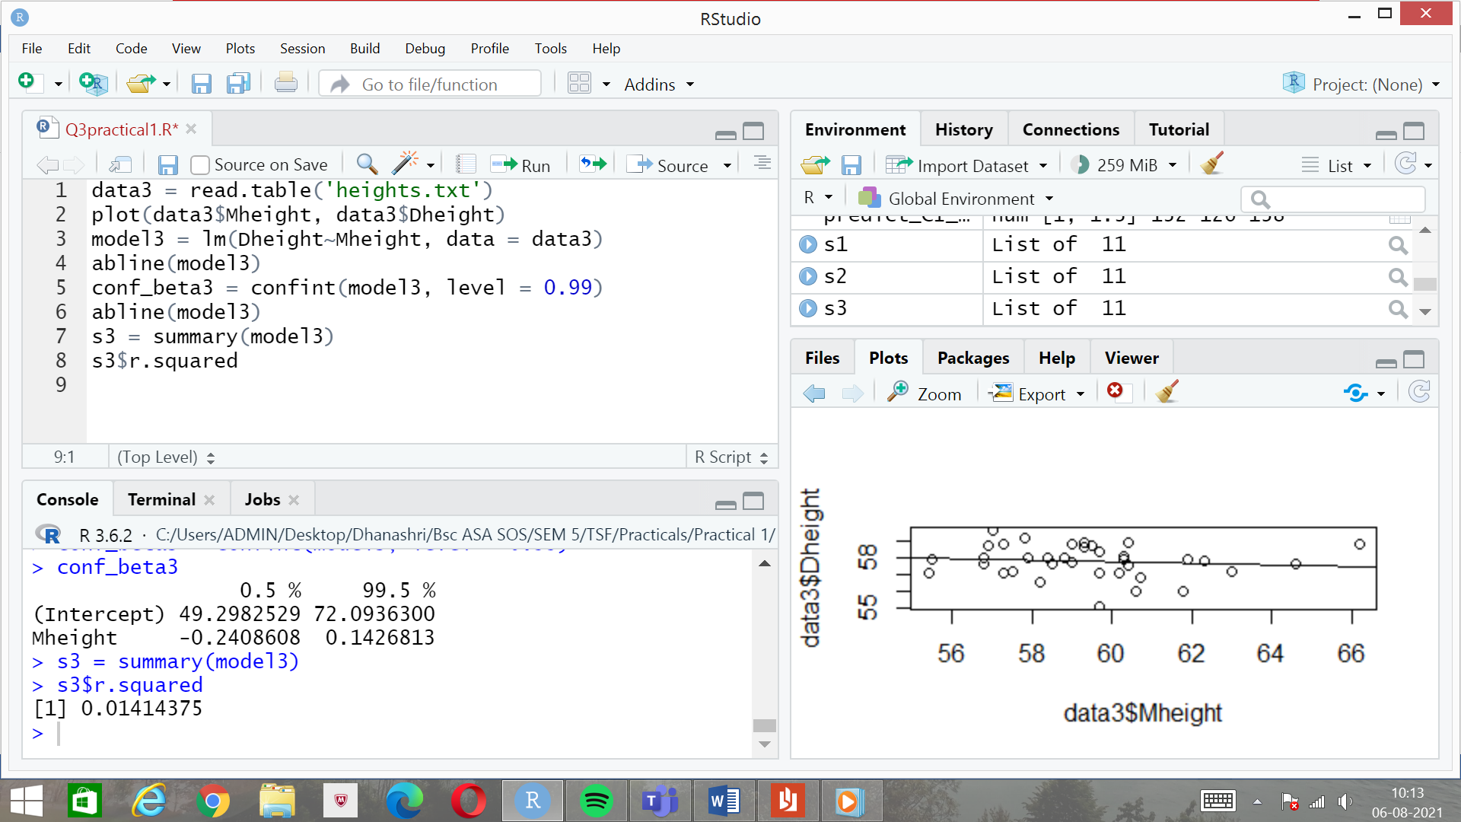

1. 99% prediction interval for a daughter whose mother is 64 inches tall:

new_data1 = data.frame(Mheight = c(64))

pred = predict(model3, interval = 'prediction', level = 0.99, newdata = new_data1)

